Ideas
Resources
- https://publicapis.dev/
- https://namelix.com/app/?keywords=interview+bot

Ideas
- RSS reader
- Password generator
- Interview prep AI assistance

AI INTERVIEW
Competition:
https://medium.com/@masonallen.official/i-tried-the-5-best-ai-interview-assistants-heres-my-honest-take-6addd4cf493c

NAMES:
- PrepPal
- InterviewBot
- InterVi
- HireBot

Mock Interview
- Industry personalized
  - Software development will ask coding-related questions. “Code Box”
- Adaptable difficulty
- Video Interviewing
  - Timed
  - Allows you to keep your video interview so you can review how you did
  - Transcription of video
- Chat Functionality
  - Asks you questions over chat
  - Gives feedback on your answers
  - Improvement

- Filter for buzz words

Resume Integration
- Personalize resume based off of job description
- Give better suggestions on how to emphasize your work experience

Interview Schedule/Calender
- Shows dates and allows you to plan when your interviews are
- Ramps difficulty of questions based off of time proximity
- Pre Interview Checklist

Progress tracking
- “Reward” for answering questions
  - Gamification
- Interview report

- Highly interactive
  - Can chat with the ai assistance

Part A - Team Charter

Part A – Team Charter
- Team Info:
  - Team name
    - Phyyve
  - Member names
    - Arlena Ung
    - Sophia Ngo
    - Danny Lo
    - Emanuel Orduna-Chin
    - Annette Rodriguez
  - Contact info
    - smngo100@gmail.com
    - arlena.ung@gmail.com
    - danny.lo01@student.csulb.edu
    - emanuelordunachin2@gmail.com
    - arra7140@gmail.com
- Roles & Responsibilities: Each member’s role and brief skill bio
  - Project Leader - Arlena
    - Responsibilities:
      - Defines project vision and success criteria
      - Coordinates team workflow
      - Reviews AI behavior
      - Works closely with the Lead AI Engineer to ensure alignment with project goals
    - Skills:
      - AI implementation with API keys
      - Strategic planning and project vision development
  - Lead AI Engineer - Danny
    - Responsibilities:
      - Builds prompts and architectures
      - Implements scoring logic
      - Integrates models
      - Handles AI guardrails
    - Skills:
      - Cloud Computing (core AWS services, network configuration, scaling cloud architecture, traffic management)
      - ML (basic model tunning)
      - GUI development (Tkinkter based ML application)
  - UI/UX Designer - Sophia
    - Responsibilities:
      - Designs user flows for interview preparation and practice
      - Creates wireframes, prototypes, and interface designs
      - Collaborates with AI and product roles on tone and pacing
    - Skills:
      - Frontend (HTML/CSS, Tailwind, JavaScript), Figma
  - AI Systems Engineer - Annette
    - Responsibilities:
      - Evaluates AI interview outputs for quality, consistency, and that it meets the team’s judgement and fairness standards
      - Identifies failure modes and pressure-tests AI edge cases
      - Works closely with AI Engineer to improve the system behavior
    - Skills:
      - Cybersecurity and Cloud Computing (Linux, VMs, AWS)
      - Network Configuration
      - Incident Response (SIEM tools)
  - Backend Engineer - Emanuel Orduna-Chin
    - Responsibilities:
      - Develops and maintains backend services and API
      - Manages interview session state and data storage
      - Ensures system reliability, security, and performance
      - Integrates backend services with AI components
    - Skills:
      - PostgresSQL, MongoDB, Python, Swift, Linux, Hardware-Software Integration
- Meeting Plan: Preferred times, tools, and communication expectations
  - Online Meetings at 9 PM
  - Discord
  - Weekly
- Working Agreements: Task tracking, decision-making, accountability methods
  - To maintain accountability and consistent progress, the team will use Jira and Trello to track tasks, deadlines, and ownership. Each task will be clearly assigned and documented to avoid ambiguity. Progress will be reviewed during weekly meetings, allowing the team to identify issues early and redistribute workload if need be.
  - Decisions will be made through group discussion and consensus whenever possible. Open communication is encouraged, and all members are expected to contribute input. If consensus cannot be reached after discussion, the project leader will make the final decision to ensure forward progress, with the option to revisit decisions if new information becomes available.
  - Team members are expected to communicate proactively if they anticipate delays or need assistance. By maintaining transparent task tracking and regular check ins, the team aims to build trust, clarity, and steady momentum throughout the project.
- Conflict Plan: What you’ll do if a teammate underperforms or disagreement arises
  - If a teammate underperforms, we will have a private, direct conversation to understand the cause, set clear expectations, and define an action plan. Since we’ll be task tracking and documenting progress throughout the project, it will be easier to recognize when a member is not completing their assigned responsibilities. For disagreements, we will address them immediately to prevent escalation, listen to understand each person’s perspective, and work to identify shared goals that can guide us toward resolution. If members cannot come to an agreement after discussion, we will refocus on the project’s primary objectives. If consensus still cannot be reached, the project leader will make the final call after considering all perspectives. There will be future opportunities to revisit the decision if new ideas or information emerge.
- Team Mission Statement:
  - Our mission is to reduce the apprehension and uneasiness users experience during interviews by building software that is personalized, effective, and transparent. We believe that technology should support users in an unpressured environment while addressing specific challenges within an increasingly competitive job market. As a team, we value empathy, thoughtful guidance, and a pleasant user experience, and we are committed to responsibly implementing AI to deliver a practical and meaningful outcome.
- Reflection Notes: Short team-written blurbs on why you chose certain norms
  - We assigned roles based on each member’s strengths and interests to maximize both efficiency and learning opportunities. Our scheduled meeting time accommodates everyone’s schedules while maintaining weekly progress checks. We chose Discord for its accessibility and real time communication. And paired it with Jira/Trello for task tracking to balance informal collaboration with professional project management. Our conflict plan emphasizes early intervention and documentation because we recognize that small issues can escalate when left unaddressed. Furthermore, our mission statement centers on empathy and transparency because we want our AI tool to feel supportive rather than judgmental.

Part B – Software Theme & Entrepreneurial Context

Part B – Software Theme & Entrepreneurial Context
- Project Idea: Description of your proposed software
  - We propose an AI powered interview prep platform that conducts personalized mock interviews through voice or chat interaction. The application provides real time feedback, integrates with user resumes, tracks progress over time, and includes scheduling tools to align practice with upcoming interview dates. Questions are tailored to match the user’s profession, experience level, and specific job requirements. We use adaptive learning to adjust difficulty based on performance and incorporate a gamified achievement system that keeps users motivated throughout their job search journey. Our AI interview bot turns interview anxiety into confidence by creating a judgment free space where users can fail, learn, and improve at their own pace.
- Problem Statement: What user need or gap it addresses
  - This software addresses the gap between knowing there is a need to prepare for interviews and actually having an accessible/personalized way of doing so. Everybody needs to look for jobs, especially students or those who are early on in their careers, who might experience interview anxiety or lack practice. Our interview preparation tool will allow users on-demand interview prep that adapts to individual experience levels, specific industries, and real interview timelines, while being rewarded through an achievement system that encourages users to practice.
- Target Audience: Who the users are, and what they value
  - The primary users will be job seekers. These include entry level candidates, career changers, experienced professionals, international candidates, or non-native speakers. These users value privacy and a safe space to fail and retry without embarrassment. They’ll seek realistic simulation such as common interview questions, competency based content, actionable feedback, affordability, and customization.
- Core Features: Initial functionality and user goals
  - Industry personalized
    - Software development will ask coding-related questions. “Code Box”
  - Adaptable difficulty
  - Video Interviewing
    - Timed
    - Allows you to keep your video interview so you can review how you did
    - Transcription of video
  - Chat Functionality
    - Asks you questions over chat
    - Gives feedback on your answers
    - Improvement
  - Filter for buzz words
  - Resume Integration
    - Personalize resume based off of job description
    - Give better suggestions on how to emphasize your work experience
  - Interview Schedule/Calender
    - Shows dates and allows you to plan when your interviews are
    - Ramps difficulty of questions based off of time proximity
    - Pre Interview Checklist
  - Progress tracking
    - “Reward” for answering questions
      - Gamification
    - Interview report
- Market Analysis: Competitor overview, potential market size
  - Sensei AI
    - Good for interview prep progress tracking
    - Con: confusing to find copilot feature
  - Verve AI
    - Persona based setup for specific roles
    - Con: confusing launch flow with misleading options
  - Interview CoPilot
    - Simple and straightforward concept
    - Con: bare minimum features
  - Potential market size
    - https://finance.yahoo.com/news/ai-assistant-market-reach-usd-073200487.html
      - The title is “AI Assistant Market to Reach USD 46.50 Billion by 2032, Driven by Enterprise Adoption, NLP Advancements, and Workflow Integration | Research by SNS Insider“
  - Competitors focus on passing the interview, but we emphasize creating a safe space to fail, learn, and improve at your own pace. While others offer static questions, we adjust difficulty based on performance progression. It keeps users engaged throughout their entire job search journey with rewards. Our application is not solely a performance tool, but an anxiety detection tool that builds genuine confidence.
- Value Proposition: What makes your software unique or valuable?
  - Our AI interview assistant combines industry-specific preparation with adaptive learning technology that will allow for a more personalized preparation journey for users when it comes to job interviews. From preparing for software development roles with integrated coding challenges to customer service positions with scenario-based questions, the difficulty will automatically scale based on performance and interview timeline. There will also be both video and chat based practice for real time transcription and buzz word analysis. These functions will provide users with instant feedback on the pacing and quality of content, ensuring a more personalized feel for the interview process and leaving the user with methods for improvement. There will be an achievement system based on performance and commitment, encouraging users to continue using the application regardless of interview status. Ultimately, the interview prep tool will reduce fear and provide a comprehensive and motivational experience for users.
- Monetization Strategy (if applicable): How the project could generate revenue
  - Revenue tiers structured as basic, standard, and premium
  - Each tier has diverse user needs and budgets
  - Basic tier (Free)
    - Users receive 5 mock interviews per month with chat interaction and basic text feedback, allowing them to experience the application’s core value before committing financially
  - Standard tier ($10 month)
    - Unlimited interviews (voice and chat), detailed feedback, full resume integration, achievement system
  - Premium tier ($15 month)
    - Video practice with body language analysis, company specific preparation, advanced analytics

Appendices

Appendices
Reflections
- Arlena Ung
  - I am looking forward to taking on the project leader role to develop my leadership and project management skills in an AI development context. I will be making sure to coordinate our team's workflow and ensure that we maintain a clear project vision and technical alignment through quality and consistency of work. I am excited to see our idea become a reality and help create something I think could help the future, especially through AI.
- Sophia Ngo
  - I’m excited to take on the UI/UX designer role to develop my skills and create interfaces that prioritize user experience. I think balancing our extensive feature set with interface simplicity will be both a challenging and engaging task, which I’ll approach through iterative prototyping.
- Danny Lo
  - I’ll be taking on the AI/LLM engineering role, and I will be responsible for building the prompt structure and overall model architecture. I will implement scoring logic to evaluate outputs, integrate the models into the application, and handle the AI guardrails. I am looking forward to developing these components and gaining more experience designing AI systems that’ll work within a larger software project.
- Emanuel Orduna-Chin
  - I’ve been tasked with working on the back-end of the project. My job is to develop and maintain backend services while ensuring system reliability, security, and performance. While I have never worked with AI, I feel comfortable with learning from my teammates and relying on their help throughout this project, and I’m excited to expand my skill set and maybe find a new passion while working together.
- Annette Rodriguez
  - I am tasked with AI Systems Engineering, where I will evaluate the resulting behavior of our AI tool and suggest steps for improvement. I believe that our team has a strong foundation in communicating equally and being open to others’ ideas. I noticed very quickly that we demonstrated psychological safety soon after meeting, and this will surely be a great sign for the next year working together. I look forward to learning about a subject outside of my expertise with our diverse team.

Collaboration
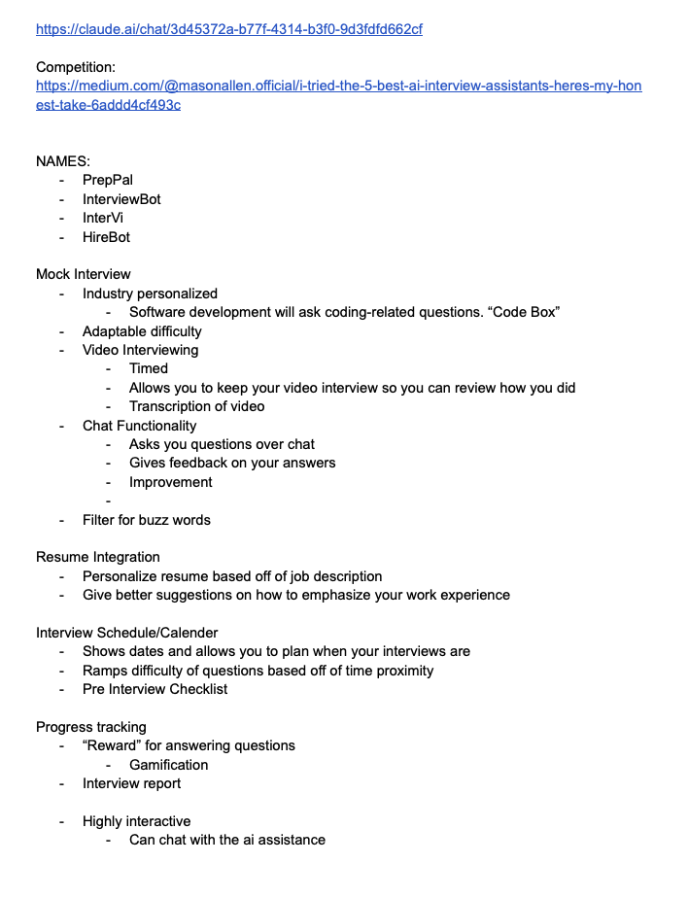 | 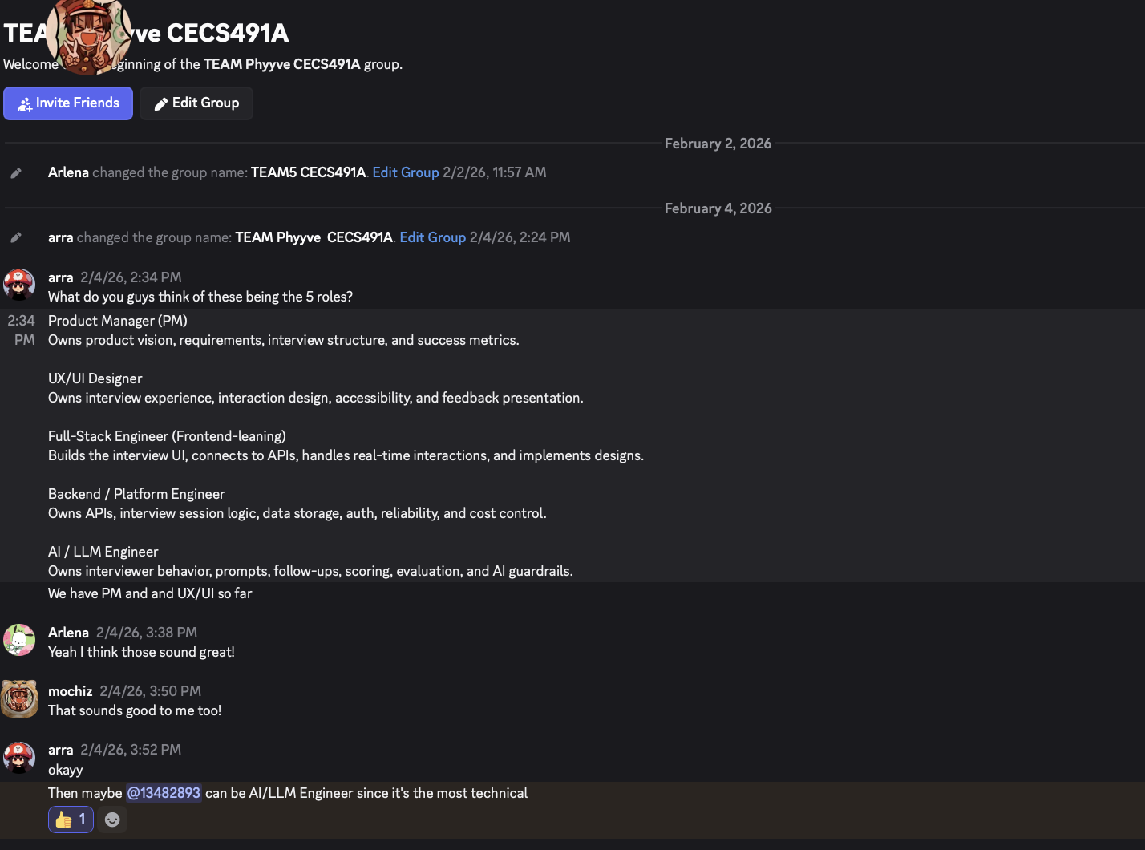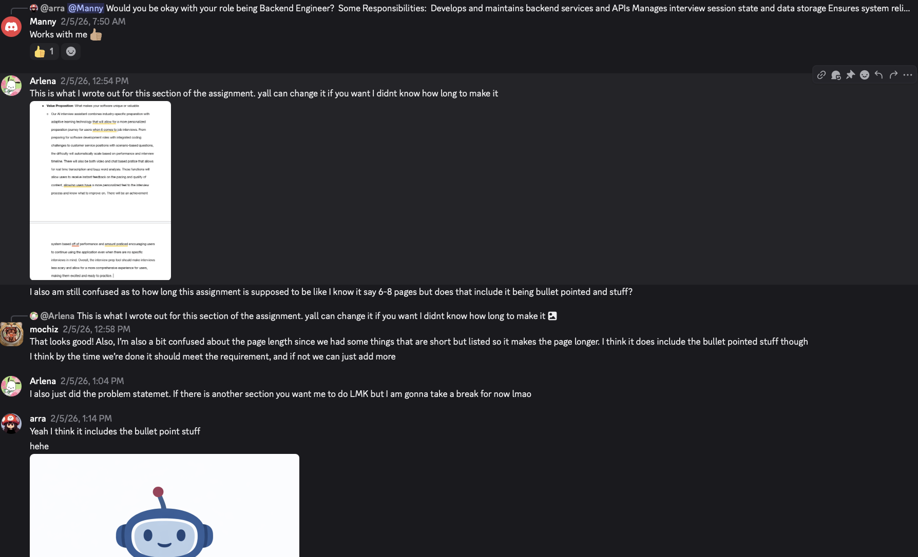

Presentation
Link to blank theme slides
Link to slides

- Project Pitch – 1 min
- Team Introduction & Mission – 2 min
- Software Overview – 2 min
- Entrepreneurial Context – 3 min
- Q&A – 2 min

Slides
- Arlena Ung
  - 1, 7, 12
- Sophia Ngo
  - 3, 4
- Danny Lo
  - 10, 11
- Emanuel Orduna-Chin
  - 8, 9
- Annette Rodriguez
  - 2,5

FINAL REPORT

Part A – Team Charter
- Team Info:
  - Team name
    - Phyyve
  - Member names
    - Arlena Ung
    - Sophia Ngo
    - Danny Lo
    - Emanuel Orduna-Chin
    - Annette Rodriguez
  - Contact info
    - smngo100@gmail.com
    - arlena.ung@gmail.com
    - danny.lo01@student.csulb.edu
    - emanuelordunachin2@gmail.com
    - arra7140@gmail.com
- Roles & Responsibilities: Each member’s role and brief skill bio
  - Project Leader - Arlena
    - Responsibilities:
      - Defines project vision and success criteria
      - Coordinates team workflow
      - Reviews AI behavior
      - Works closely with the Lead AI Engineer to ensure alignment with project goals
    - Skills:
      - AI implementation with API keys
      - Strategic planning and project vision development
  - Lead AI Engineer - Danny
    - Responsibilities:
      - Builds prompts and architectures
      - Implements scoring logic
      - Integrates models
      - Handles AI guardrails
    - Skills:
      - Cloud Computing (core AWS services, network configuration, scaling cloud architecture, traffic management)
      - ML (basic model tunning)
      - GUI development (Tkinkter based ML application)
  - UI/UX Designer - Sophia
    - Responsibilities:
      - Designs user flows for interview preparation and practice
      - Creates wireframes, prototypes, and interface designs
      - Collaborates with AI and product roles on tone and pacing
    - Skills:
      - Frontend (HTML/CSS, Tailwind, JavaScript), Figma
  - AI Systems Engineer - Annette
    - Responsibilities:
      - Evaluates AI interview outputs for quality, consistency, and that it meets the team’s judgement and fairness standards
      - Identifies failure modes and pressure-tests AI edge cases
      - Works closely with AI Engineer to improve the system behavior
    - Skills:
      - Cybersecurity and Cloud Computing (Linux, VMs, AWS)
      - Network Configuration
      - Incident Response (SIEM tools)
  - Backend Engineer - Emanuel Orduna-Chin
    - Responsibilities:
      - Develops and maintains backend services and API
      - Manages interview session state and data storage
      - Ensures system reliability, security, and performance
      - Integrates backend services with AI components
    - Skills:
      - PostgresSQL, MongoDB, Python, Swift, Linux, Hardware-Software Integration
- Meeting Plan: Preferred times, tools, and communication expectations
  - Online Meetings at 9 PM
  - Discord
  - Weekly
- Working Agreements: Task tracking, decision-making, accountability methods
  - To maintain accountability and consistent progress, the team will use Jira and Trello to track tasks, deadlines, and ownership. Each task will be clearly assigned and documented to avoid ambiguity. Progress will be reviewed during weekly meetings, allowing the team to identify issues early and redistribute workload if need be.
  - Decisions will be made through group discussion and consensus whenever possible. Open communication is encouraged, and all members are expected to contribute input. If consensus cannot be reached after discussion, the project leader will make the final decision to ensure forward progress, with the option to revisit decisions if new information becomes available.
  - Team members are expected to communicate proactively if they anticipate delays or need assistance. By maintaining transparent task tracking and regular check ins, the team aims to build trust, clarity, and steady momentum throughout the project.
- Conflict Plan: What you’ll do if a teammate underperforms or disagreement arises
  - If a teammate underperforms, we will have a private, direct conversation to understand the cause, set clear expectations, and define an action plan. Since we’ll be task tracking and documenting progress throughout the project, it will be easier to recognize when a member is not completing their assigned responsibilities. For disagreements, we will address them immediately to prevent escalation, listen to understand each person’s perspective, and work to identify shared goals that can guide us toward resolution. If members cannot come to an agreement after discussion, we will refocus on the project’s primary objectives. If consensus still cannot be reached, the project leader will make the final call after considering all perspectives. There will be future opportunities to revisit the decision if new ideas or information emerge.
- Team Mission Statement:
  - Our mission is to reduce the apprehension and uneasiness users experience during interviews by building software that is personalized, effective, and transparent. We believe that technology should support users in an unpressured environment while addressing specific challenges within an increasingly competitive job market. As a team, we value empathy, thoughtful guidance, and a pleasant user experience, and we are committed to responsibly implementing AI to deliver a practical and meaningful outcome.
- Reflection Notes: Short team-written blurbs on why you chose certain norms
  - We assigned roles based on each member’s strengths and interests to maximize both efficiency and learning opportunities. Our scheduled meeting time accommodates everyone’s schedules while maintaining weekly progress checks. We chose Discord for its accessibility and real time communication. And paired it with Jira/Trello for task tracking to balance informal collaboration with professional project management. Our conflict plan emphasizes early intervention and documentation because we recognize that small issues can escalate when left unaddressed. Furthermore, our mission statement centers on empathy and transparency because we want our AI tool to feel supportive rather than judgmental.

Part B – Software Theme & Entrepreneurial Context
- Project Idea: Description of your proposed software
  - We propose an AI powered interview prep platform that conducts personalized mock interviews through voice or chat interaction. The application provides real time feedback, integrates with user resumes, tracks progress over time, and includes scheduling tools to align practice with upcoming interview dates. Questions are tailored to match the user’s profession, experience level, and specific job requirements. We use adaptive learning to adjust difficulty based on performance and incorporate a gamified achievement system that keeps users motivated throughout their job search journey. Our AI interview bot turns interview anxiety into confidence by creating a judgment free space where users can fail, learn, and improve at their own pace.
- Problem Statement: What user need or gap it addresses
  - This software addresses the gap between knowing there is a need to prepare for interviews and actually having an accessible/personalized way of doing so. Everybody needs to look for jobs, especially students or those who are early on in their careers, who might experience interview anxiety or lack practice. Our interview preparation tool will allow users on-demand interview prep that adapts to individual experience levels, specific industries, and real interview timelines, while being rewarded through an achievement system that encourages users to practice.
- Target Audience: Who the users are, and what they value
  - The primary users will be job seekers. These include entry level candidates, career changers, experienced professionals, international candidates, or non-native speakers. These users value privacy and a safe space to fail and retry without embarrassment. They’ll seek realistic simulation such as common interview questions, competency based content, actionable feedback, affordability, and customization.
- Core Features: Initial functionality and user goals
  - Industry personalized
    - Software development will ask coding-related questions. “Code Box”
  - Adaptable difficulty
  - Video Interviewing
    - Timed
    - Allows you to keep your video interview so you can review how you did
    - Transcription of video
  - Chat Functionality
    - Asks you questions over chat
    - Gives feedback on your answers
    - Improvement
  - Filter for buzz words
  - Resume Integration
    - Personalize resume based off of job description
    - Give better suggestions on how to emphasize your work experience
  - Interview Schedule/Calender
    - Shows dates and allows you to plan when your interviews are
    - Ramps difficulty of questions based off of time proximity
    - Pre Interview Checklist
  - Progress tracking
    - “Reward” for answering questions
      - Gamification
    - Interview report
- Market Analysis: Competitor overview, potential market size
  - Sensei AI
    - Good for interview prep progress tracking
    - Con: confusing to find copilot feature
  - Verve AI
    - Persona based setup for specific roles
    - Con: confusing launch flow with misleading options
  - Interview CoPilot
    - Simple and straightforward concept
    - Con: bare minimum features
  - Potential market size
    - https://finance.yahoo.com/news/ai-assistant-market-reach-usd-073200487.html
      - The title is “AI Assistant Market to Reach USD 46.50 Billion by 2032, Driven by Enterprise Adoption, NLP Advancements, and Workflow Integration | Research by SNS Insider“
  - Competitors focus on passing the interview, but we emphasize creating a safe space to fail, learn, and improve at your own pace. While others offer static questions, we adjust difficulty based on performance progression. It keeps users engaged throughout their entire job search journey with rewards. Our application is not solely a performance tool, but an anxiety detection tool that builds genuine confidence.
- Value Proposition: What makes your software unique or valuable?
  - Our AI interview assistant combines industry-specific preparation with adaptive learning technology that will allow for a more personalized preparation journey for users when it comes to job interviews. From preparing for software development roles with integrated coding challenges to customer service positions with scenario-based questions, the difficulty will automatically scale based on performance and interview timeline. There will also be both video and chat based practice for real time transcription and buzz word analysis. These functions will provide users with instant feedback on the pacing and quality of content, ensuring a more personalized feel for the interview process and leaving the user with methods for improvement. There will be an achievement system based on performance and commitment, encouraging users to continue using the application regardless of interview status. Ultimately, the interview prep tool will reduce fear and provide a comprehensive and motivational experience for users.
- Monetization Strategy (if applicable): How the project could generate revenue
  - Revenue tiers structured as basic, standard, and premium
  - Each tier has diverse user needs and budgets
  - Basic tier (Free)
    - Users receive 5 mock interviews per month with chat interaction and basic text feedback, allowing them to experience the application’s core value before committing financially
  - Standard tier ($10 month)
    - Unlimited interviews (voice and chat), detailed feedback, full resume integration, achievement system
  - Premium tier ($15 month)
    - Video practice with body language analysis, company specific preparation, advanced analytics

Appendices
Reflections
- Arlena Ung
  - I am looking forward to taking on the project leader role to develop my leadership and project management skills in an AI development context. I will be making sure to coordinate our team's workflow and ensure that we maintain a clear project vision and technical alignment through quality and consistency of work. I am excited to see our idea become a reality and help create something I think could help the future, especially through AI.
- Sophia Ngo
  - I’m excited to take on the UI/UX designer role to develop my skills and create interfaces that prioritize user experience. I think balancing our extensive feature set with interface simplicity will be both a challenging and engaging task, which I’ll approach through iterative prototyping.
- Danny Lo
  - I’ll be taking on the AI/LLM engineering role, and I will be responsible for building the prompt structure and overall model architecture. I will implement scoring logic to evaluate outputs, integrate the models into the application, and handle the AI guardrails. I am looking forward to developing these components and gaining more experience designing AI systems that’ll work within a larger software project.
- Emanuel Orduna-Chin
  - I’ve been tasked with working on the back-end of the project. My job is to develop and maintain backend services while ensuring system reliability, security, and performance. While I have never worked with AI, I feel comfortable with learning from my teammates and relying on their help throughout this project, and I’m excited to expand my skill set and maybe find a new passion while working together.
- Annette Rodriguez
  - I am tasked with AI Systems Engineering, where I will evaluate the resulting behavior of our AI tool and suggest steps for improvement. I believe that our team has a strong foundation in communicating equally and being open to others’ ideas. I noticed very quickly that we demonstrated psychological safety soon after meeting, and this will surely be a great sign for the next year working together. I look forward to learning about a subject outside of my expertise with our diverse team.

Collaboration

